Pond Identification Sheet

Insects & Arthropods
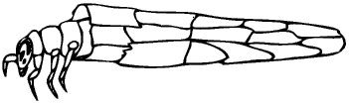 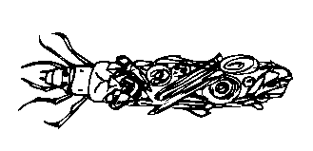Caddisfly larvae

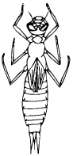dragonfly nymph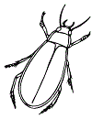diving beetle 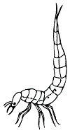 diving beetle larvae
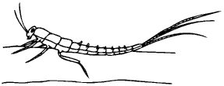 mayfly nymph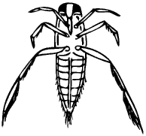water boatman

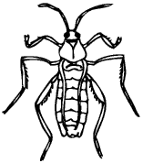water cricket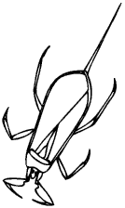water scorpion 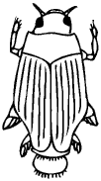whirlygig beetle

Protozoans and Small Animals

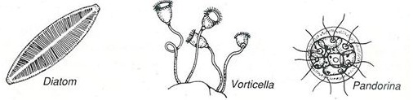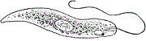Euglena
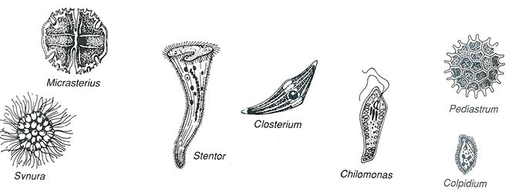
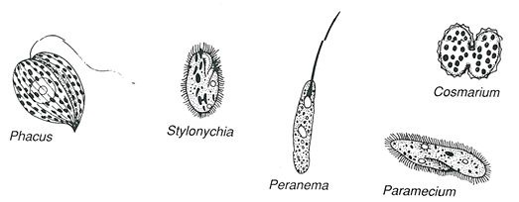
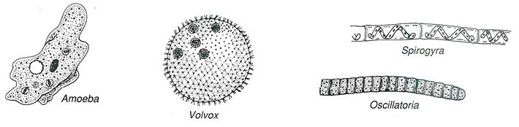
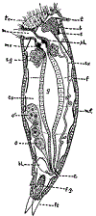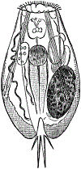Rotifers 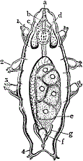Waterbear (tardigrade)
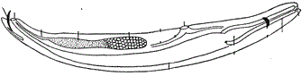Nematode 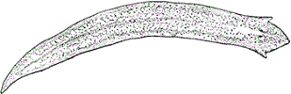Planarian
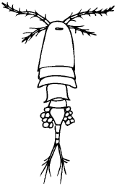cyclops 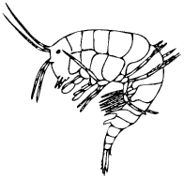water shrimp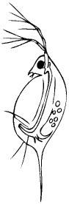water flea (Daphnia)

Algae and Other Microorganisms
Volvox (green)Haematococcus (red colored)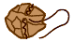dinoflagellate (red, green, some multicolored)
Desmids (green)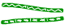Spirogyra (green)
Anything green and stringy can be classified as an algae!!!

