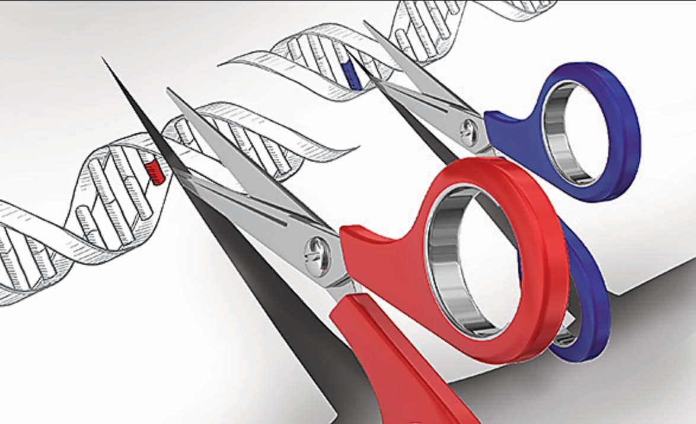
What Is CRISPR?
By Aparna Vidyasagar, Live Science Contributor | April 21, 2017 09:47pm ET
Retrieved from: https://www.livescience.com/58790-crispr-explained.html

CRISPR technology is a simple yet powerful tool for editing genomes. It allows researchers to easily alter DNA sequences and modify gene function. Its many potential applications include correcting genetic defects, treating and preventing the spread of diseases and improving crops. However, its promise also raises ethical concerns.

In popular usage, "CRISPR" (pronounced "crisper") is shorthand for "CRISPR-Cas9." CRISPRs are specialized stretches of DNA. The protein Cas9 (or "CRISPR-associated") is an enzyme that acts like a pair of molecular scissors, capable of cutting strands of DNA.
CRISPR technology was adapted from the natural defense mechanisms of bacteria and archaea (the domain of single-celled microorganisms). These organisms use CRISPR-derived RNA and various Cas proteins, including Cas9, to foil attacks by viruses and other foreign bodies. They do so primarily by chopping up and destroying the DNA of a foreign invader. When these components are transferred into other, more complex, organisms, it allows for the manipulation of genes, or "editing."

CRISPR-Cas9: The key players
CRISPRs: "CRISPR" stands for "clusters of regularly interspaced short palindromic repeats." It is a specialized region of DNA with two distinct characteristics: the presence of nucleotide repeats and spacers. Repeated sequences of nucleotides — the building blocks of DNA — are distributed throughout a CRISPR region. Spacers are bits of DNA that are interspersed among these repeated sequences.

In the case of bacteria, the spacers are taken from viruses that previously attacked the organism. They serve as a bank of memories, which enables bacteria to recognize the viruses and fight off future attacks.
This was first demonstrated experimentally by Rodolphe Barrangou and a team of researchers at Danisco, a food ingredients company. In a 2007 paper published in the journal Science, the researchers used Streptococcus thermophilus bacteria, which are commonly found in yogurt and other dairy cultures, as their model. They observed that after a virus attack, new spacers were incorporated into the CRISPR region. Moreover, the DNA sequence of these spacers was identical to parts of the virus genome. They also manipulated the spacers by taking them out or putting in new viral DNA sequences. In this way, they were able to alter the bacteria's resistance to an attack by a specific virus. Thus, the researchers confirmed that CRISPRs play a role in regulating bacterial immunity.
CRISPR RNA (crRNA): Once a spacer is incorporated and the virus attacks again, a portion of the CRISPR is transcribed and processed into CRISPR RNA, or "crRNA." The nucleotide sequence of the CRISPR acts as a template to produce a complementary sequence of single-stranded RNA. Each crRNA consists of a nucleotide repeat and a spacer portion, according to a 2014 review by Jennifer Doudna and Emmanuelle Charpentier, published in the journal Science.
Cas9: The Cas9 protein is an enzyme that cuts foreign DNA.
The protein typically binds to two RNA molecules: crRNA and another called tracrRNA (or "trans-activating crRNA"). The two then guide Cas9 to the target site where it will make its cut. This expanse of DNA is complementary to a 20-nucleotide stretch of the crRNA.
Using two separate regions, or "domains" on its structure, Cas9 cuts both strands of the DNA double helix, making what is known as a "double-stranded break," according to the 2014 Science article.
There is a built-in safety mechanism, which ensures that Cas9 doesn't just cut anywhere in a genome. Short DNA sequences known as PAMs ("protospacer adjacent motifs") serve as tags and sit adjacent to the target DNA sequence. If the Cas9 complex doesn't see a PAM next to its target DNA sequence, it won't cut. This is one possible reason that Cas9 doesn't ever attack the CRISPR region in bacteria, according to a 2014 review published in Nature Biotechnology.

CRISPR-Cas9 as a genome-editing tool
The genomes of various organisms encode a series of messages and instructions within their DNA sequences. Genome editing involves changing those sequences, thereby changing the messages. This can be done by inserting a cut or break in the DNA and tricking a cell's natural DNA repair mechanisms into introducing the changes one wants. CRISPR-Cas9 provides a means to do so.
In 2012, two pivotal research papers were published in the journals Science and PNAS, which helped transform bacterial CRISPR-Cas9 into a simple, programmable genome-editing tool.
The studies, conducted by separate groups, concluded that Cas9 could be directed to cut any region of DNA. This could be done by simply changing the nucleotide sequence of crRNA, which binds to a complementary DNA target. In the 2012 Science article, Martin Jinek and colleagues further simplified the system by fusing crRNA and tracrRNA to create a single "guide RNA." Thus, genome editing requires only two components: a guide RNA and the Cas9 protein.
"Operationally, you design a stretch of 20 [nucleotide] base pairs that match a gene that you want to edit," said George Church, Robert Winthrop Professor of Genetics at Harvard Medical School. An RNA molecule complementary to those 20 base pairs is constructed. Church emphasized the importance of making sure that the nucleotide sequence is found only in the target gene and nowhere else in the genome. "Then the RNA plus the protein [Cas9] will cut — like a pair of scissors — the DNA at that site, and ideally nowhere else," he explained.
Once the DNA is cut, the cell's natural repair mechanisms kick in and work to introduce mutations or other changes to the genome. There are two ways this can happen. According to the Huntington's Outreach Project at Stanford (University), one repair method involves gluing the two cuts back together. This method, known as "non-homologous end joining," tends to introduce errors. Nucleotides are accidentally inserted or deleted, resulting in mutations, which could disrupt a gene. In the second method, the break is fixed by filling in the gap with a sequence of nucleotides. In order to do so, the cell uses a short strand of DNA as a template. Scientists can supply the DNA template of their choosing, thereby writing-in any gene they want, or correcting a mutation.
Utility and limitations
CRISPR-Cas9 has become popular in recent years. Church notes that the technology is easy to use and is about four times more efficient than the previous best genome-editing tool (called TALENS).
In 2013, the first reports of using CRISPR-Cas9 to edit human cells in an experimental setting were published by researchers from the laboratories of Church and Feng Zhang of the Broad Institute of the Massachusetts Institute of Technology and Harvard. Studies using in vitro (laboratory) and animal models of human disease have demonstrated that the technology can be effective in correcting genetic defects. Examples of such diseases include cystic fibrosis, cataracts and Fanconi anemia, according to a 2016 review article published in the journal Nature Biotechnology. These studies pave the way for therapeutic applications in humans.
CRISPR technology has also been applied in the food and agricultural industries to engineer probiotic cultures and to vaccinate industrial cultures (for yogurt, for example) against viruses. It is also being used in crops to improve yield, drought tolerance and nutritional properties.
One other potential application is to create gene drives. These are genetic systems, which increase the chances of a particular trait passing on from parent to offspring. Eventually, over the course of generations, the trait spreads through entire populations, according to the Wyss Institute. Gene drives can aid in controlling the spread of diseases such as malaria by enhancing sterility among the disease vector — female Anopheles gambiae mosquitoes — according to the 2016 Nature Biotechnology article. In addition, gene drives could also be used to eradicate invasive species and reverse pesticide and herbicide resistance, according to a 2014 article by Kenneth Oye and colleagues, published in the journal Science.
However, CRISPR-Cas9 is not without its drawbacks.
"I think the biggest limitation of CRISPR is it is not a hundred percent efficient," Church told Live Science. Moreover, the genome-editing efficiencies can vary. According to the 2014 Science article by Doudna and Charpentier, in a study conducted in rice, gene editing occurred in nearly 50 percent of the cells that received the Cas9-RNA complex. Whereas, other analyses have shown that depending on the target, editing efficiencies can reach as high as 80 percent or more.
There is also the phenomenon of "off-target effects," where DNA is cut at sites other than the intended target. This can lead to the introduction of unintended mutations. Furthermore, Church noted that even when the system cuts on target, there is a chance of not getting a precise edit. He called this "genome vandalism."

Setting limits
The many potential applications of CRISPR technology raise questions about the ethical merits and consequences of tampering with genomes.
In the 2014 Science article, Oye and colleagues point to the potential ecological impact of using gene drives. An introduced trait could spread beyond the target population to other organisms through crossbreeding. Gene drives could also reduce the genetic diversity of the target population.
Making genetic modifications to human embryos and reproductive cells such as sperm and eggs is known as germline editing. Since changes to these cells can be passed on to subsequent generations, using CRISPR technology to make germline edits has raised a number of ethical concerns.
Variable efficacy, off-target effects and imprecise edits all pose safety risks. In addition, there is much that is still unknown to the scientific community. In a 2015 article published in Science, David Baltimore and a group of scientists, ethicists and legal experts note that germline editing raises the possibility of unintended consequences for future generations "because there are limits to our knowledge of human genetics, gene-environment interactions, and the pathways of disease (including the interplay between one disease and other conditions or diseases in the same patient)."
Other ethical concerns are more nuanced. Should we make changes that could fundamentally affect future generations without having their consent? What if the use of germline editing veers from being a therapeutic tool to an enhancement tool for various human characteristics?
To address these concerns, the National Academies of Sciences, Engineering and Medicine put together a comprehensive report with guidelines and recommendations for genome editing.
Although the National Academies urge caution in pursuing germline editing, they emphasize "caution does not mean prohibition." They recommend that germline editing be done only on genes that lead to serious diseases and only when there are no other reasonable treatment alternatives. Among other criteria, they stress the need to have data on the health risks and benefits and the need for continuous oversight during clinical trials. They also recommend following up on families for multiple generations.

Questions: As you read, find information in the text that can help you answer the questions below. Also keep track of vocabulary words or ideas that confuse you.

- What is CRISPR and where was it adapted from?
- How might CRISPR help human populations?
- How might CRISPR harm human populations?
- Based on what you’ve read so far, do you think CRISPR is helpful or harmful to human populations?

